Q2







Q3

the possible H0 and corresponding t-statistics, p-values, as well as reject or not are as follows:

Max_depth = 3

t statistics for DT and BT Ttest_indResult(statistic=0.0, pvalue=1.0)

Reject with significance level of 0.05? False

t statistics for DT and RF Ttest_indResult(statistic=0.4835578640114232, pvalue=0.634529733356133)

Reject with significance level of 0.05? False

t statistics for BT and RF Ttest_indResult(statistic=0.4835578640114232, pvalue=0.634529733356133)

Reject with significance level of 0.05? False

max_depth 5

t statistics for DT and BT Ttest_indResult(statistic=0.032484201631099045, pvalue=0.9744434122718826)

Reject with significance level of 0.05? False

t statistics for DT and RF Ttest_indResult(statistic=0.511727208138217, pvalue=0.615062662583669)

Reject with significance level of 0.05? False

t statistics for BT and RF Ttest_indResult(statistic=0.5244267216135824, pvalue=0.6063804711612376)

Reject with significance level of 0.05? False

max_depth 7

t statistics for DT and BT Ttest_indResult(statistic=-0.8817598765755686, pvalue=0.3895298569337393)

Reject with significance level of 0.05? False

t statistics for DT and RF Ttest_indResult(statistic=-1.239849296234129, pvalue=0.23095222023761763)

Reject with significance level of 0.05? False

t statistics for BT and RF Ttest_indResult(statistic=-0.2969903479705387, pvalue=0.769873844485174)

Reject with significance level of 0.05? False

max_depth 9

t statistics for DT and BT Ttest_indResult(statistic=-2.457864091118732, pvalue=0.024344527663678128)

Reject with significance level of 0.05? False

t statistics for DT and RF Ttest_indResult(statistic=-3.0778818043232326, pvalue=0.006485443203191372)

Reject with significance level of 0.05? True

t statistics for BT and RF Ttest_indResult(statistic=-0.030610651298706076, pvalue=0.9759169066027166)

Reject with significance level of 0.05? False

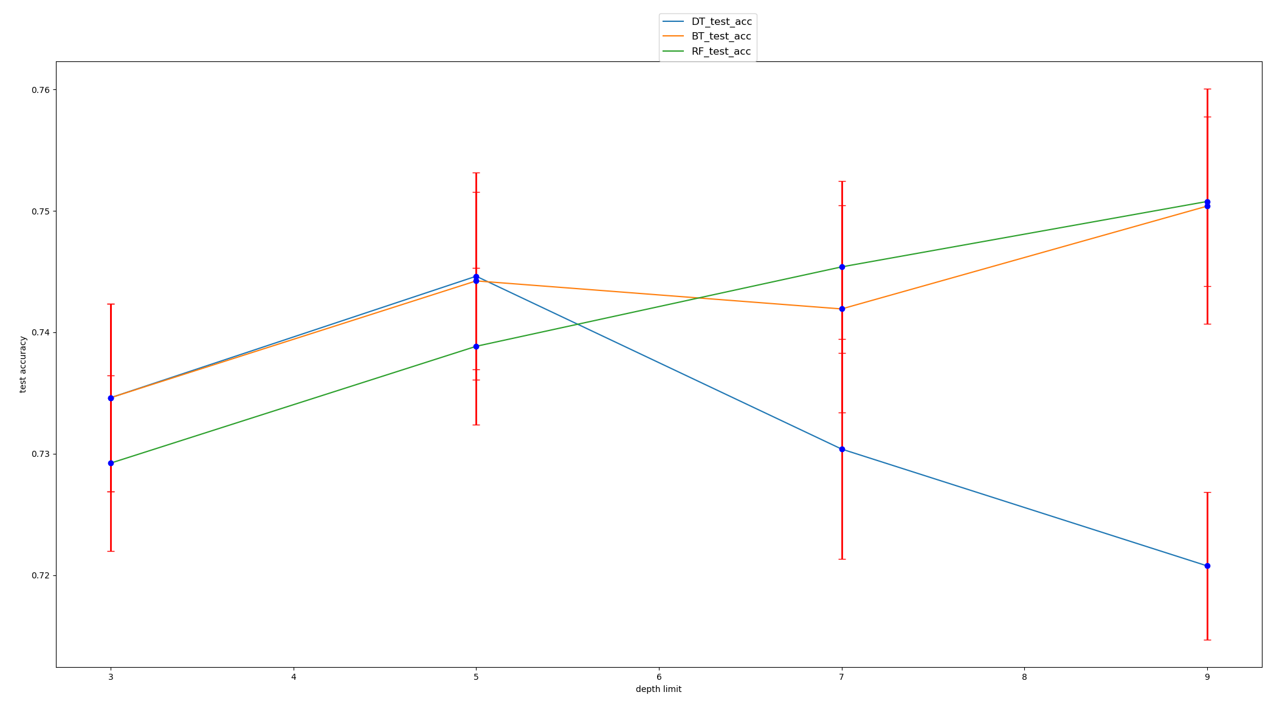

Q4

fraction= 0.05

t statistics for DT and BT Ttest_indResult(statistic=-2.9827212385803383, pvalue=0.007979513365337055)

Reject with significance level of 0.05? True

t statistics for DT and RF Ttest_indResult(statistic=-4.8169390409896105, pvalue=0.00013819454277568495)

Reject with significance level of 0.05? True

t statistics for BT and RF Ttest_indResult(statistic=-1.7808339563752051, pvalue=0.09182315122969055)

Reject with significance level of 0.05? False

fraction= 0.075

t statistics for DT and BT Ttest_indResult(statistic=-1.7258091627370278, pvalue=0.10150676399583934)

Reject with significance level of 0.05? False

t statistics for DT and RF Ttest_indResult(statistic=-2.8650528177041608, pvalue=0.010292733251254982)

Reject with significance level of 0.05? True

t statistics for BT and RF Ttest_indResult(statistic=-1.4452715823380833, pvalue=0.16556704177403245)

Reject with significance level of 0.05? False

fraction= 0.1

t statistics for DT and BT Ttest_indResult(statistic=-1.588582309964174, pvalue=0.12956485731381542)

Reject with significance level of 0.05? False

t statistics for DT and RF Ttest_indResult(statistic=-1.5334480006724285, pvalue=0.1425540694736587)

Reject with significance level of 0.05? False

t statistics for BT and RF Ttest_indResult(statistic=0.08953229620715322, pvalue=0.9296475897445705)

Reject with significance level of 0.05? False

fraction= 0.15

t statistics for DT and BT Ttest_indResult(statistic=-3.3650118159193205, pvalue=0.00344850507689105)

Reject with significance level of 0.05? True

t statistics for DT and RF Ttest_indResult(statistic=-3.790440540418209, pvalue=0.0013396255782792024)

Reject with significance level of 0.05? True

t statistics for BT and RF Ttest_indResult(statistic=-0.06301105941147013, pvalue=0.9504521494669398)

Reject with significance level of 0.05? False

fraction= 0.2

t statistics for DT and BT Ttest_indResult(statistic=-3.753922324989718, pvalue=0.0014531886807905006)

Reject with significance level of 0.05? True

t statistics for DT and RF Ttest_indResult(statistic=-4.483866989473235, pvalue=0.00028703564821292755)

Reject with significance level of 0.05? True

t statistics for BT and RF Ttest_indResult(statistic=-0.9142442529014525, pvalue=0.3726733668622828)

Reject with significance level of 0.05? False

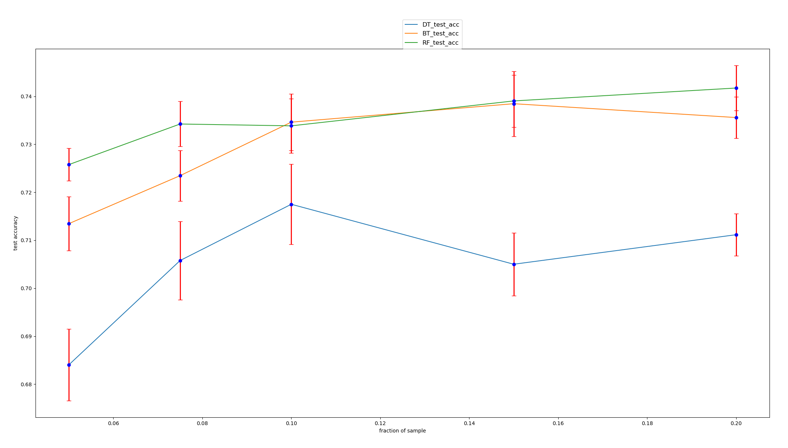

Q5

number of trees 10

t statistics for BT and RF Ttest_indResult(statistic=-0.2652622026586088, pvalue=0.7938215130524097)

Reject with significance level of 0.05? False

number of trees 20

t statistics for BT and RF Ttest_indResult(statistic=0.5144957554275207, pvalue=0.6131648523829409)

Reject with significance level of 0.05? False

number of trees 40

t statistics for BT and RF Ttest_indResult(statistic=-0.2700894819638073, pvalue=0.7901636886043473)

Reject with significance level of 0.05? False

number of trees 50

t statistics for BT and RF Ttest_indResult(statistic=0.12745778659862209, pvalue=0.8999912047048391)

Reject with significance level of 0.05? False

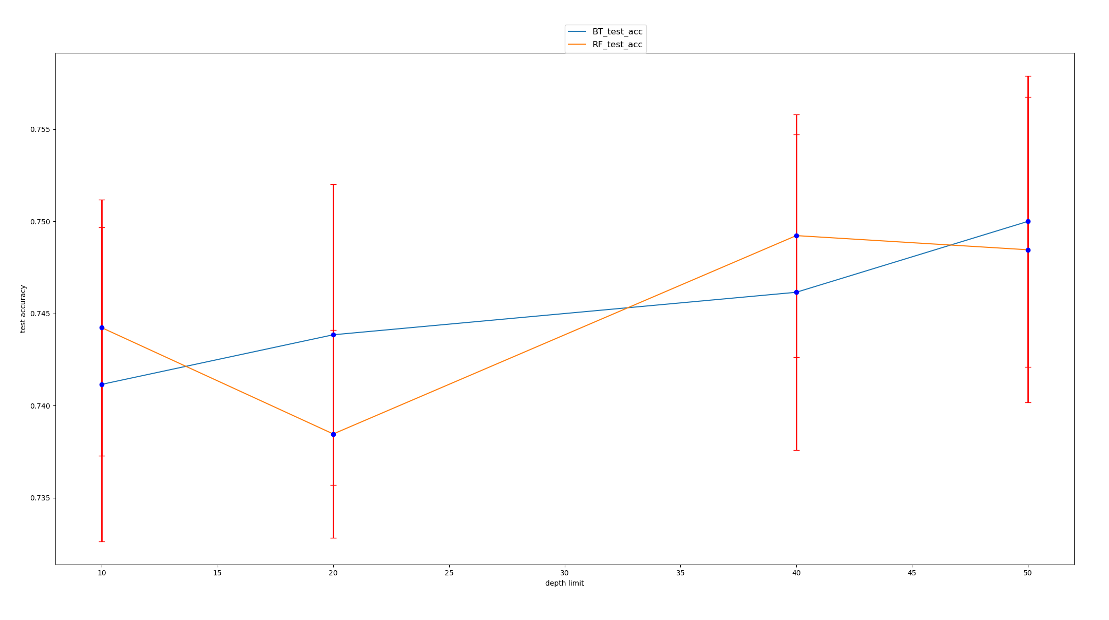

Number of trees